**MVC Pattern – Model- View – Controller Pattern**

MVC is a pattern for organising code in an application to improve maintainability.

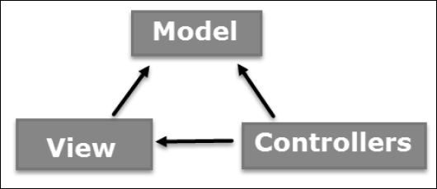

# The Model

* The model defines what data the app should contain
* The model is responsible for managing the program’s data.
* A model could be a single object or it could be some structure of objects
* Model contains NO view/Controller code
* Model NEVER tells View/Controller what to do
* The model in To-Do app, it defines tasks or the list of Task

# The View

* View is a visual representation of app and defines how the app’s data should be displayed.
* This part deals with UI and trigger action in controller for DOM Event Handling

- e.g. user clicks ‘add task’ button

- e.g. a new task appears on screen (data displayed from the model)

# The Controller

* This is the middle person acting on both model and view.
* The Controller is responsible for handling request and connecting between Model and View.
* The Controller handles external input to the system invoking modification of Model.
* It controls the data flow into model object and updates the view whenever data changes. It keeps view and model separate.

# The Router

* Selects the right controller to handle a request

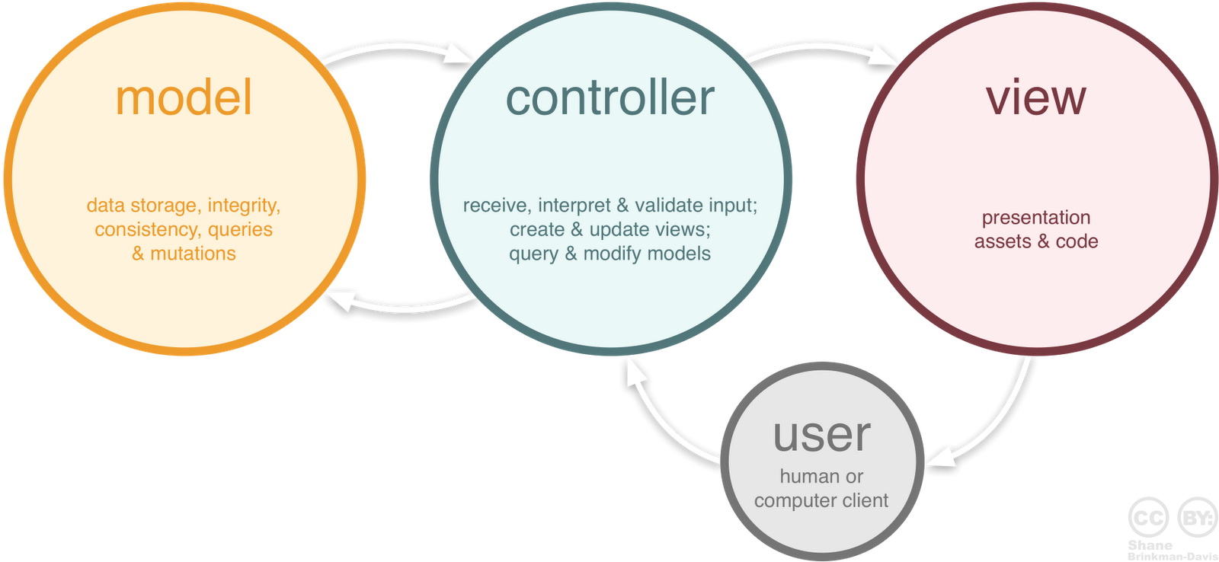

# **Flow Steps**

**Step 1** − The client browser sends request to the MVC Application.

**Step 2** – app.ts receives this request, and pass the request to the appropriate controller.

**Step 3** − The Controller processes the data using Model and invokes the appropriate method using ControllerActionInvoker object

**Step 4** − The processed Model is then passed to the View, which in turn renders the final output.

# **MVC in Action**

<https://www.tutorialspoint.com/design_pattern/mvc_pattern.htm>